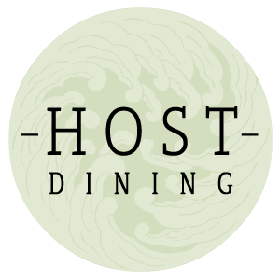

Café de Paris butter / nigella seeded lemon focaccia / crispy onions [6,7,11,13]
Walnut soup / tarragon sourdough croutons [2,6,7]
Asparagus / nori / watercress broth / goats cheese snow / lemon oil [6]
Spelt battered sweet potato / katsu curry sauce / pickles / samphire and cucumber salad [3,6,7,8]
Poached vegetable wontons / split wild garlic sauce / crispy sage / cured egg yolk [6,9,13]
Tonka bean panna cotta / burnt white chocolate / soy sauce and orange gel / hazelnut brittle [2,6,8]
Dark chocolate and gouda Ice cream sandwich [2,6,7,9]

14 known allergens-all allergens are listed after each ingredient on the menu
If you have any other allergens or are vegetarian, please inform us when booking as certain dietary requirements cannot be catered for due to the nature of the event.
1, peanuts/2, tree nuts /3, fish/4, crustacean/5, molluscs/6, milk/7, cereals containing gluten/8, soybeans/9, eggs/10, sesame seeds/11, mustard/12, celery/13, sulphites/14, lupin

