Belgrade Ensemble 26/27 – Application Form Questions

Thank you for your interest in the Belgrade Ensemble.
Please fill out the form on Microsoft Forms. Alternatively, you can complete in Word and email the form along with your CV and Self-Tape to communityadmin@belgrade.co.uk with the subject line ‘Belgrade Ensemble – [Your Name]’.

Application & Selection Process Timeline
- Application Deadline: Friday 11 September 2026 at 10am. (Late applications cannot be accepted),
- Shortlisting Outcome: We will contact all applicants with the outcome of their application as soon as possible after the deadline,
- Live Workshop Auditions: Friday 25 September and Saturday 26 September (at the Belgrade Theatre, Coventry).

Please refer to our online FAQ sheet if you have any questions or need guidance to complete this form.

Privacy Notice
The information you provide here will be held confidentially and stored safely. It will only be shared with the creative and management team members leading this project. For further details on how we use and look after your data, please see our Privacy Policy on our website: Privacy Policy - Belgrade Theatre.

SECTION 1: ABOUT YOU

First Name:
Surname:
Phone Number:
Email Address:
Date of Birth:
(Applicants must be 18 or over by 13 October 2026. There is no upper age limit).
Home Address:

Postcode:
(You must live within a 25-mile radius or 30mns travel time of Coventry) Coventry).

SECTION 2: ELIGIBILITY & CULTURAL REPRESENTATION
This year's ensemble will portray a group of Maroon women in our flagship production of Nanny of the Maroons. Under Schedule 9, Part 1 of the Equality Act 2010 (Genuine Occupational Requirement), we are specifically recruiting Black, female-presenting artists.
Do you identify as Black, or of Black African / Caribbean diaspora heritage ? Yes / No
Do you identify as female or female-presenting? (We warmly welcome cisgender women, transgender women, and non-binary individuals who feel comfortable and aligned with playing these roles and exploring female narratives).Yes / No

SECTION 3: BACKGROUND & TRAINING
1. Are you currently in formal drama school training, or have you previously completed vocational acting training (at BA Hons level or above)? Yes / No
2. Have you applied to the Belgrade Ensemble in previous years? Yes / No
3. Have you taken part in any other Belgrade Theatre programmes before? (e.g., youth groups, Adult Acting, Young Company, school workshops, Community Casts). Yes No
If yes, please state which programme(s) and when:
4. Please tell us about any other experience you have with performing (singing, acting, movement). This could include (but not limited to) drama at school, foundation acting courses, community shows, youth theatre, or local choirs.

SECTION 4: AVAILABILITY FOR AUDITIONS, REHEARSALS AND PERFORMANCES
- Auditions
If shortlisted, you will be invited to a relaxed group workshop audition consisting of an individual monologue performance, an individual song performance, and a collaborative movement workshop.
Please tick ALL slots you are available to attend. (Selecting more than one helps us with scheduling):
Friday 25 September 2026
Slot A: 10am – 1pm
Slot B: 2pm – 5pm
Saturday 26 September 2026
Slot A: 10am – 1pm
Slot B: 2pm – 5pm

- Regular Rehearsals
The Belgrade Ensemble 26/27 runs on Tuesday evenings (6:30pm – 9:30pm) from Tuesday 13 October 2026 until Tuesday 13 July 2027. Can you commit to attending regular Tuesday evening rehearsals? Yes / No / Maybe
If 'Maybe', please share any details about your schedule or potential conflicts:

- Intensive Week
The Belgrade Ensemble will be performing their own show the week of 8-13 March 2027. We would require full availability (10am-10pm) that week. Please let us know if you are available/are able to make yourself available during that week
Yes / No / Maybe
If 'Maybe', please share any details about your schedule or potential conflicts:

- Nanny Of The Maroons

A big part of this year's Belgrade Ensemble programme is participation in Nanny of the Maroons rehearsals and performances. Please see a schedule below (note this is subject to change). Are you able to commit to attending all rehearsals & performances?
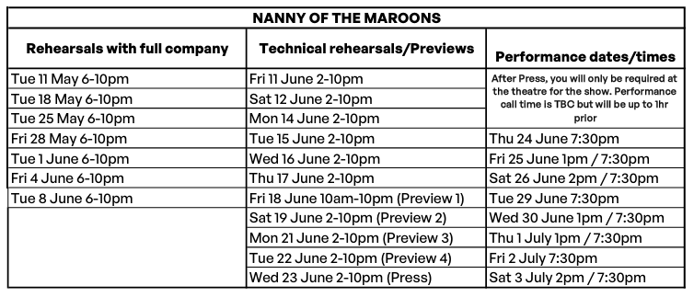
Yes / No / Maybe
If 'Maybe', please share any details about your schedule or potential conflicts:

SECTION 5: Supporting Documents and Access Requirements
- Your CV
As part of your application, we need a copy of your current CV. This can include your performance experience, but it doesn't have.
Please either upload it to a file sharing platform (such as Google Drive) and the paste the link below, or email communityadmin@belgrade.co.ukwith the subject line "BELGRADE ENSEMBLE Application: CV"

- Your Self-Tape Video (A 1-minute monologue and a 1-minute song).
As part of your application, we need you to record a Self-Tape. Please either upload it to a sharing platform (such as YouTube, Vimeo, Google Drive, or WeTransfer) and paste the link below, or email communityadmin@belgrade.co.uk with the subject line "BELGRADE ENSEMBLE Application: Self-Tape"

3. If we invite you for an audition, do you have any access requirements? This could include physical access requirements, communication preferences, tools like coloured paper, etc.

4. How did you hear about the Belgrade Ensemble? (e.g., social media, university/college, word of mouth, theatre flyer).

